**User manual**

You can open the project in Eclipse or just simply open the **cs370Project.jar** file.

If your want to **run from eclipse:** Right click on the project and click on run and select run as java application

After you go the **main page** you have option to search as the guest, of create account or just login if you have an account.

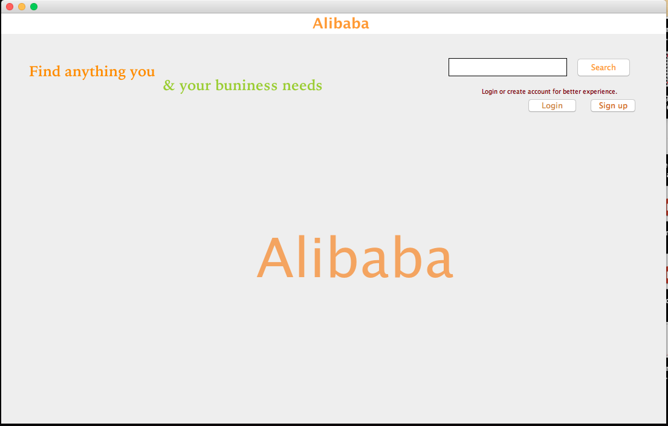

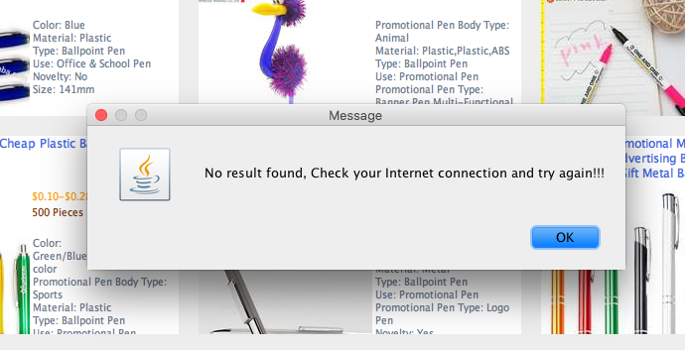**To search**: type your key word and click on search button. You will get a message if you have internet connection problem, you have to try again if the message displays.

**To create account:** click on signup and fill up the information and click on Create Account.

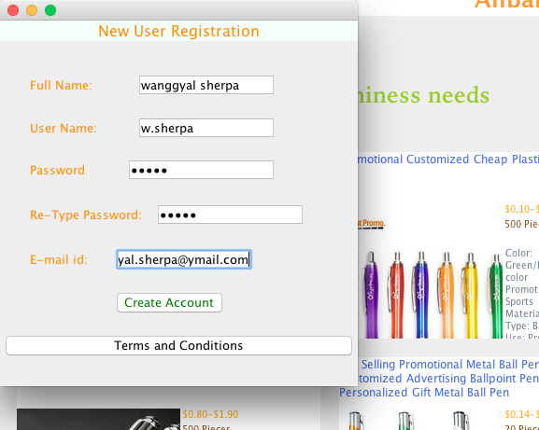

**To Login:** After your have created your account you can now login using your username and password.

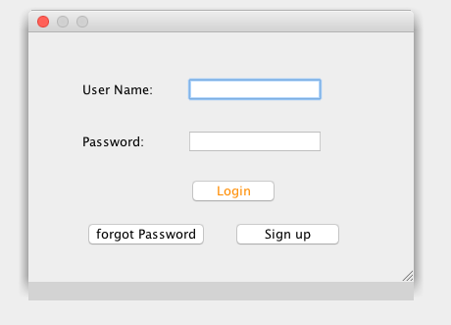

After Login you can search anything you want and your **history** will be save in the history, which can be accessed by clicking on **menu** on the left top corner.

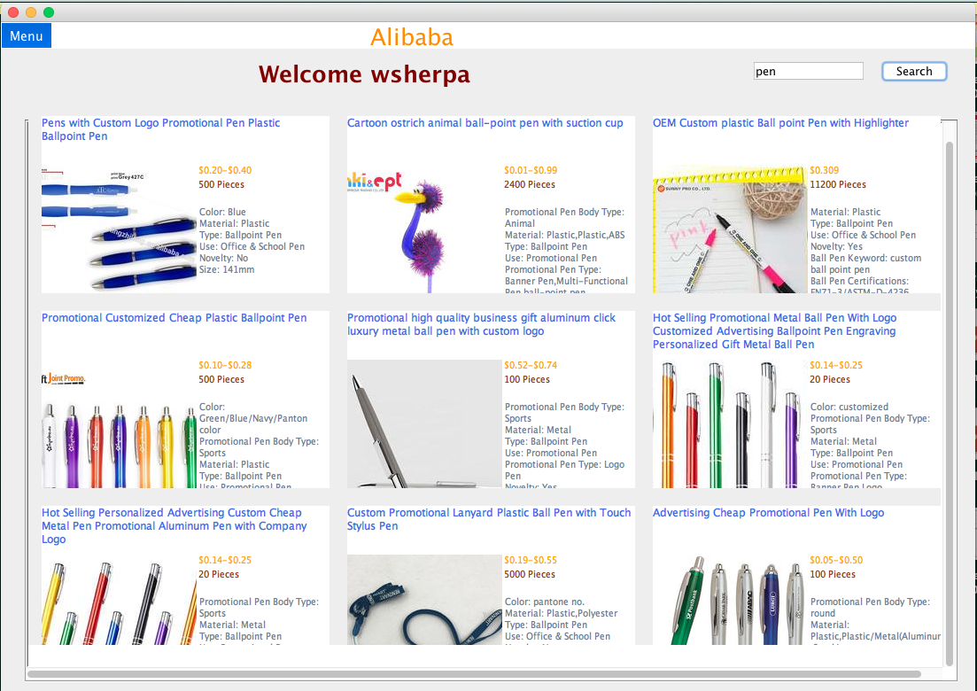

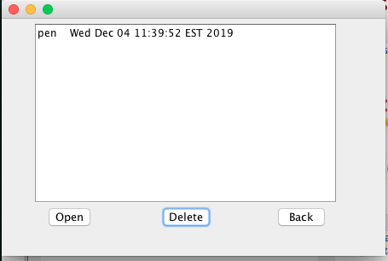

You can **delete** your history or **open** it. If you don’t want to change anything just click on back button or close this window.

**To Log out** : click on **menu** and click on **logout.**